**Installation manual**

CEMM Plus

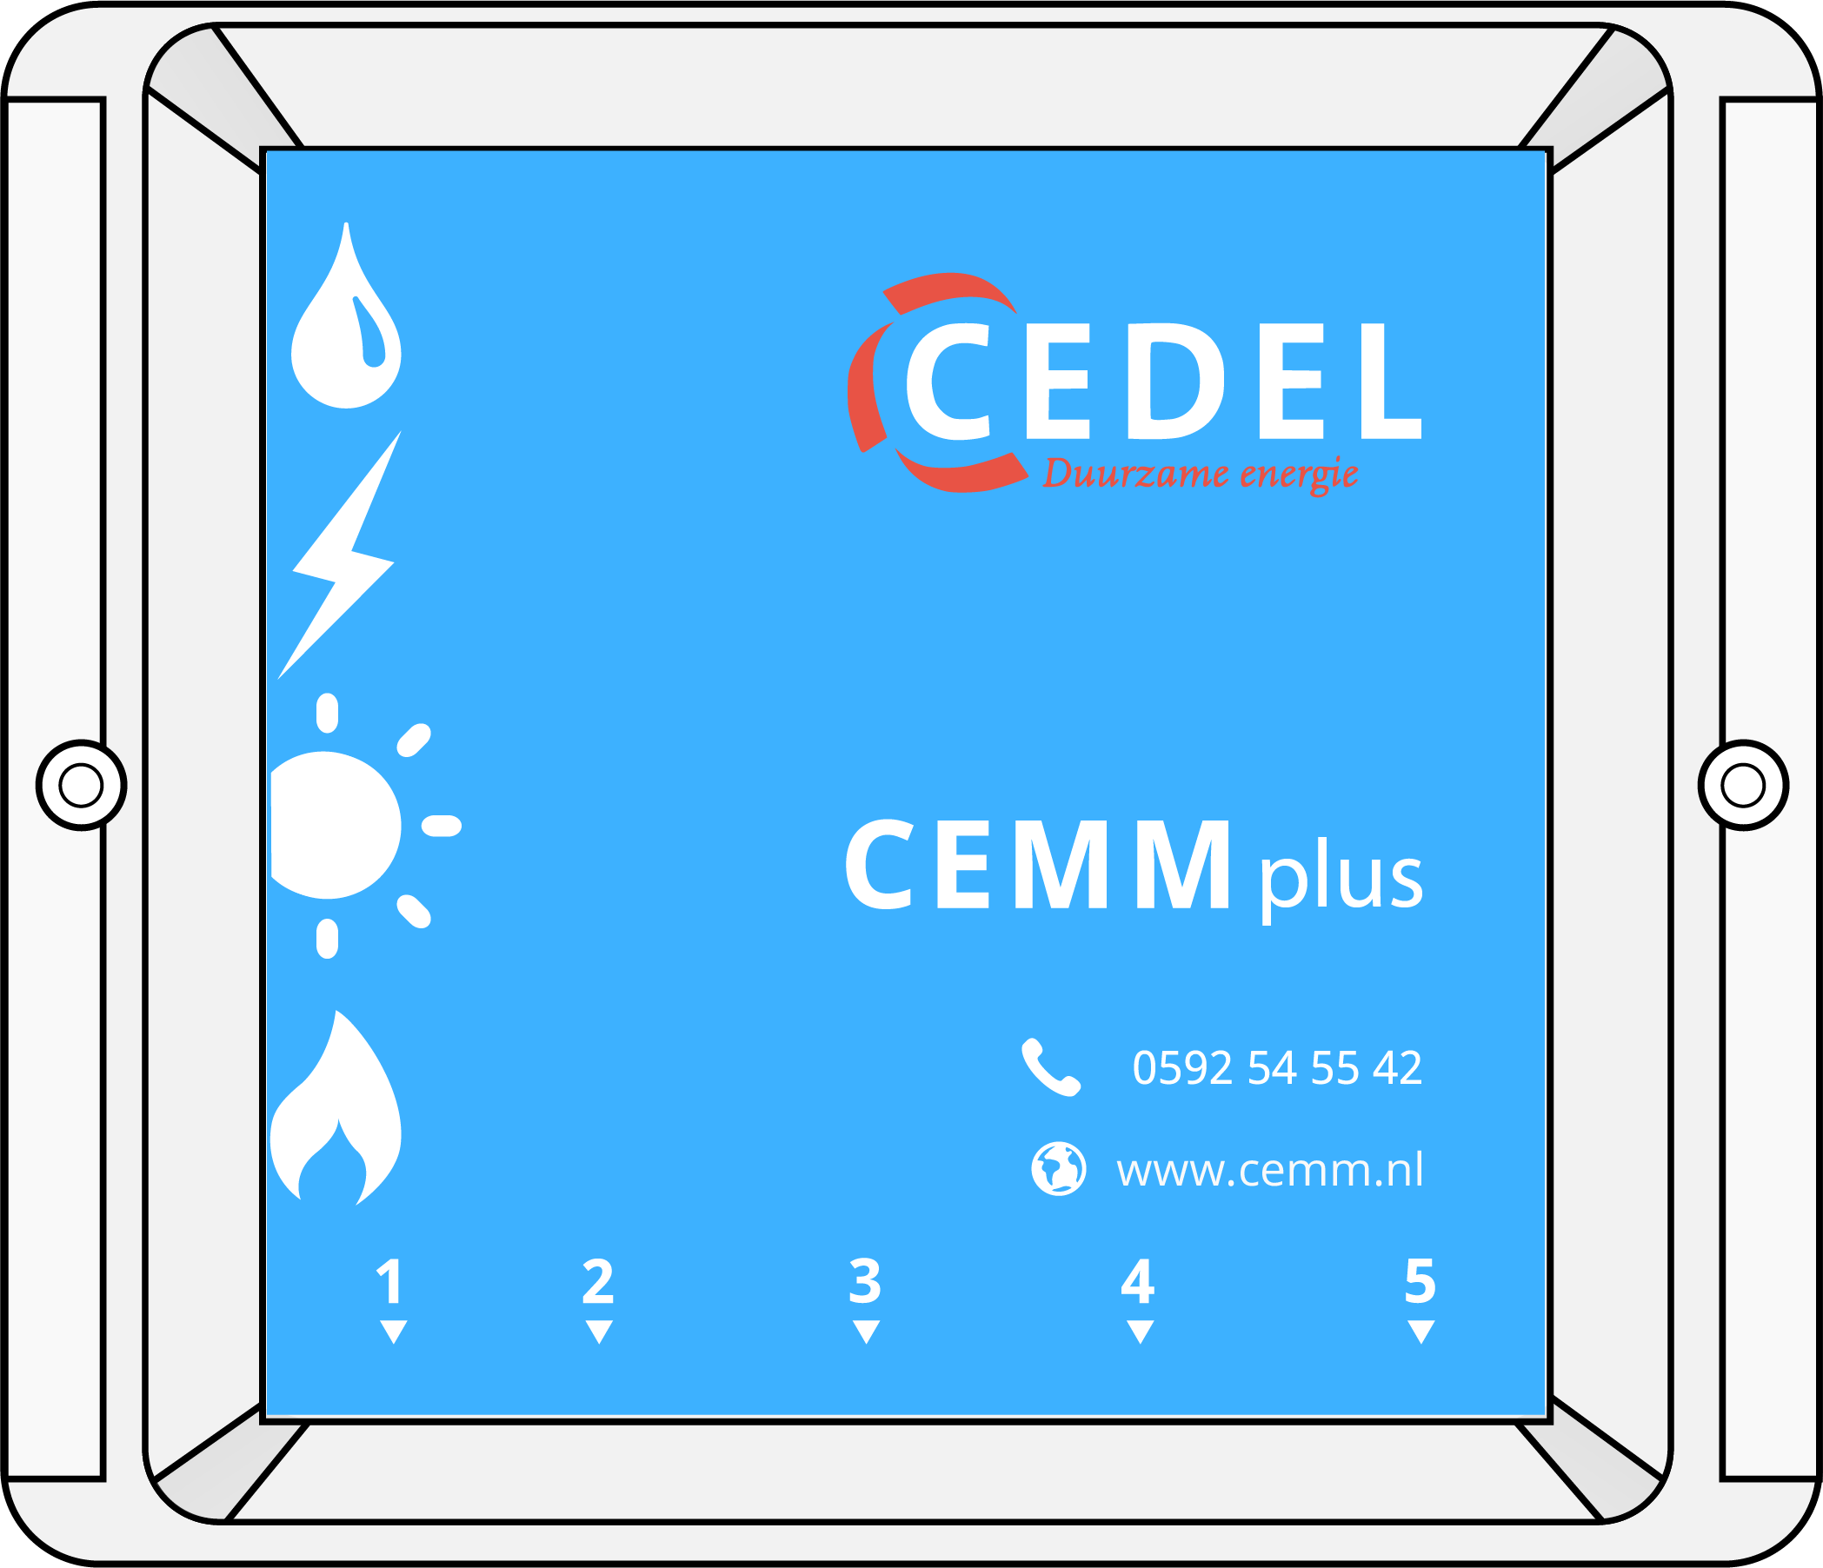

1. Installation CEMM Plus

**Before installation**

This manual contains a step by step description of the CEMM Plus installation. Before installation check if all components listed below are included.

**Included in the package**

▶ CEMM Plus

▶ Two screws + plugs

▶ P1 cable (for DSMR meters)

▶ Power adapter

▶ Network cable

**Installation requirements**

▶ Network connection near the CEMM Plus

▶ Wall socket near the CEMM Plus

▶ Computer or smartphone with internet browser

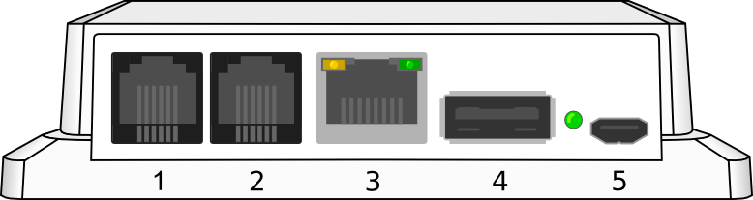

**CEMM Plus connections**1. Smart meter (P1 DSMR) / pulse input  
2. Pulse input  
3. Network  
4. USB (Modbus USB converter)  
5. Power

**Step 1: Mounting the CEMM Plus**

Screw the CEMM Plus on the wall with the screws included in the package. The CEMM Plus needs to be mounted with the connectors facing down and the text on the front readable. Place the CEMM Plus near an internet connection and wall socket.

**Step 2: Connect the CEMM Plus with a smart meter (optional)**

The CEMM Plus supports smart meters with the DSMR protocol and a P1 port. Skip this step if no suitable smart meter is available.

Use the included P1 cable to connect the smart meter with **connection 1** of the CEMM Plus. Check the manual of the smart meter to locate the P1 port on the smart meter.

**Step 3: Connect the CEMM Plus to the network**

Use the included network cable to connect the CEMM Plus with your local network. Connect the other end of the network cable with **connection 3** of the CEMM Plus.

**Step 4: Connect the power adapter**

Connect the power adapter to **connection 5** of the CEMM Plus. The CEMM Plus will start automatically. The startup can take a few minutes. The LED next to the power connection of the CEMM Plus will start blinking when the CEMM is ready.

**Step 5: Opening the CEMM Plus application**An internet browser is needed in order to view the CEMM Plus application**.** Open your internet browser and browse to the following url:

**▶ Via http://zoek.cemm.nl (recommend)**

Go to <http://zoek.cemm.nl> in the browser. The website will search for your CEMM Plus in the network andautomatically redirects to the CEMM Plus application if both devices are in the same local network.

**▶ Via the hostname**

The CEMM Plus will identify itself with hostname “cemm” in your local network. You can access the CEMM Plus application by typing in the hostname in the browser.

On Windows computers: [**http://cemm**](http://cemm/)**/**

On Apple of Linux computers: [**http://cemm.local**](http://cemm.local/)**/**

**Attention:** The device you are using to access the CEMM Plus needs to be in the same local network as the CEMM Plus.

 **It is possible to access the CEMM Plus outside of your local network. Enable the remote access feature in the CEMM Plus application after the installation. You can find more information about remote access on our website**

**▶** [**www.cemm.nl/remote-access**](http://www.cemm.nl/remote-access)

**Step 6: Configure the CEMM Plus**

The CEMM Plus will startup in installation mode if the CEMM Plus is not configured for logging. The installation mode will help you to configure the CEMM Plus step by step.

 **The CEMM Plus will install the latest software version during the installation, this may take several minutes. After the software is installed, you will be automatically redirected to the installation page.**

2. Installation Modbus meters

**Before installation**

This manual covers the installation of the Eastron **SDM120** and **SDM630** kWh meters. You can find a list of supported meters on <http://www.cemm.nl/cemm-plus/>

 All electrical installations should be carried out by a qualified electrician.

**Installation requirements**  
▶ CEMM Plus  
▶ Modbus kWh meters  
▶ USB converter  
▶ Modbus cable

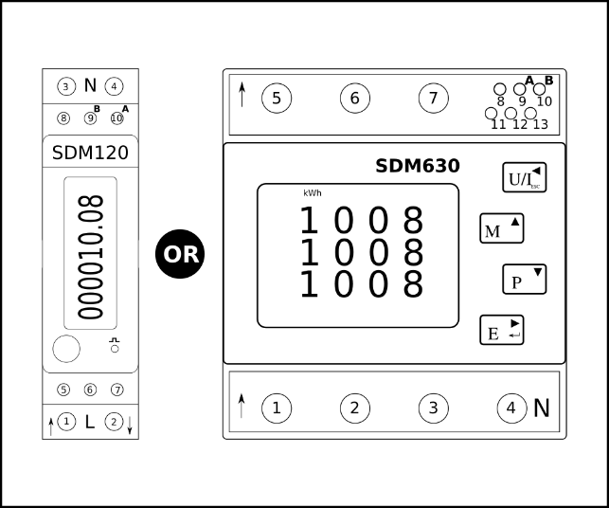

Figure 1 The CEMM Plus supports Eastron SDM120 and SDM630 kWh meters

**Installing the Modbus meters (electrically)**

Install the Modbus meter in a suitable location. Make sure the meter only measures the energy you want to monitor. For example, if you want to monitor a single group, place the meter after the circuit breaker of that group.

**Installing the SDM120 (1 phase kWh meter)**

The wiring diagram for the single phase kWh meter is printed on the side of the meter.

*The installation of a kWh meter should be carried out by a qualified electrician.*

**Installing the SDM630 (3 phase kWh meter)**

The wiring diagram for the three-phase kWh meter can be found in the manual supplied with the meter. If you do not have the manual of the meter you can download the manual from <http://www.cemm.nl/support/>

*The installation of a kWh meter should be carried out by a qualified electrician.*

**Modbus cable**

Good communication between the Modbus meters and the CEMM Plus is partly determined by the quality of the Modbus cable. We recommend using a cable suitable for RS-485 (Modbus) applications.

If you do not want to use a special Modbus cable at least make sure that the cable is twisted pair and shielded.

**Attention!** The use of an unsuitable cable can result in unstable measurement results by poor communication with the Modbus meter.

**Connecting the Modbus cable**

The Modbus cable must be connected to all the energy meters and the CEMM Plus. Connect the Modbus cable in a way that there is only one end to connect with the CEMM Plus. See Figure 2 for an example connection with 3 meters.

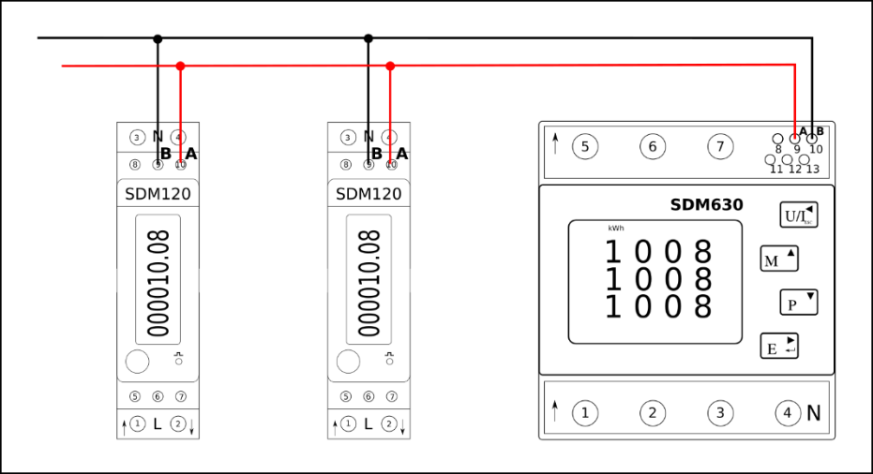

Figure 2 Example connection Modbus meters

The two cores of the Modbus cable must be properly connected to the energy meters. All **A** terminals must be connected to the same (color) core and all **B** terminals should be connected to the other (color) core. See Table 1 and Figure 3 for the connections of the meters.

**Attention!!** *The order of the* ***A*** *and* ***B*** *terminals may vary between meter types.*

**Attention!!** *The colors used in this manual are indicative. The actual core colors depend on the type of cable that is used*

|  |  |  |
| --- | --- | --- |
|  | **A** | **B** |
| Modbus connection terminals **SDM120** | 10 | 9 |
| Modbus connection terminals **SDM630** | 9 | 10 |

Table 1 Modbus connection terminals SDM120 and SDM630

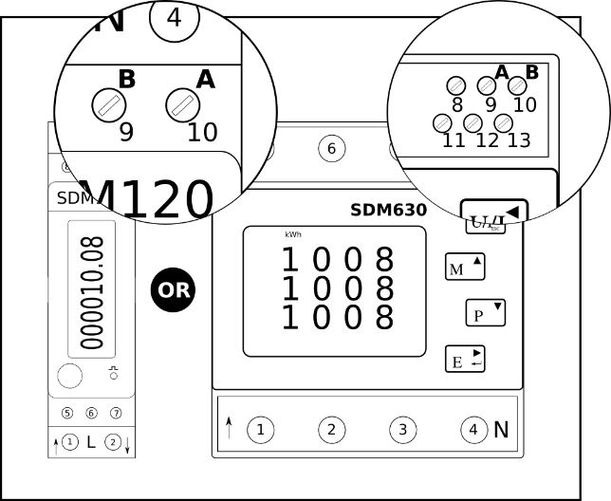

Figure 3 Modbus connection terminals SDM120 and SDM630

**Connect the Modbus USB converter**

Connect the end of the Modbus cable to the USB converter, see Figure 4. The USB converter is connected to the CEMM Plus in

connection **4**. See Figure 5 for the overall configuration.

**Attention!!** *The order of the A and B terminals may vary. Check the markings on the USB converter.*

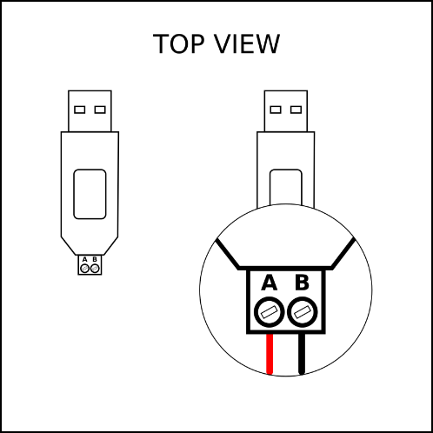

*Figure 4 Modbus connection USB converter*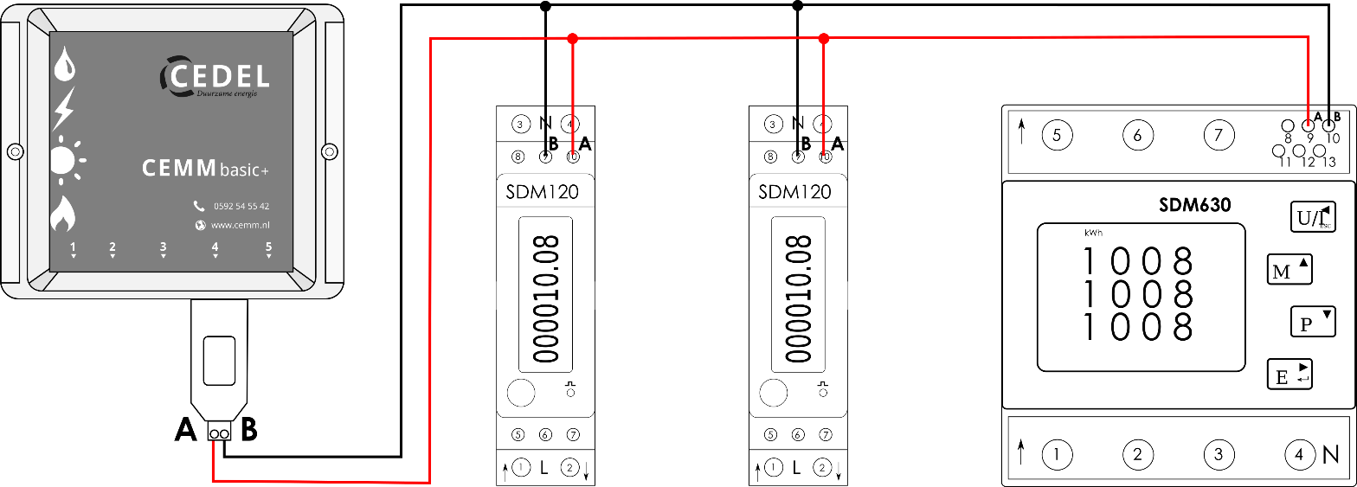

*Figure 5 Example overview 3 Modbus meters connected to the CEMM Plus*

**Open the CEMM Plus application**

If all Modbus meters are connected, you can continue configuring the meters in the CEMM application.

Refer to the installation guide of the CEMM Plus if it is not installed. (First part of this manual)

Open the CEMM application in the browser of your computer.

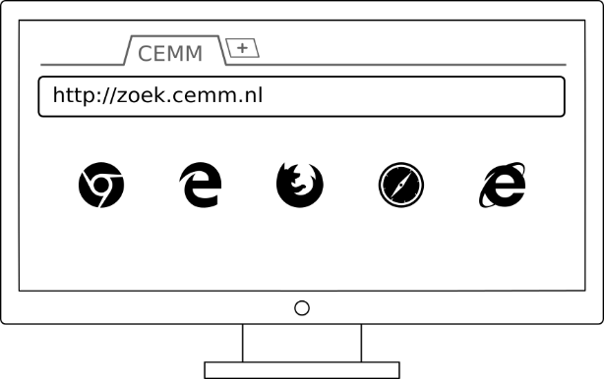

**Register Modbus meters in the application**

The Modbus meters connected in the previous steps must be configured in the application so the CEMM can start logging the data.

* Open the **Settings** page in the application. You will see the **Meter settings** page.
* Click the **Add Meter** button and choose **Modbus meters** from the list.

The Modbus installation wizard opens. Follow the instructions on the screen to configure the Modbus meter.

Keep repeating the steps above until all meters are configured in the CEMM application.

**The CEMM Plus is now configured to monitor your Modbus meters.**

**EXTRA INFORMATION**

**Modbus meter address**

Each Modbus meter that is connected to the CEMM must have a unique address. This address is necessary to distinguish between the meters that are connected.

New Modbus meters have a default address **1**. The default address must be changed into a unique address.

The CEMM can set a new address in the meter registration process. The meter has to be put into configuration mode in order to let the CEMM change the address.

**Modbus meter configuration mode**

The configuration mode is used to configure a Modbus meter programmatically. The configuration mode must be enabled manually. The configuration mode remains active for a few minutes, after that the meter returns to its normal mode.

See Appendix **I** for the steps to put the SDM120 in configuration mode.

See Appendix **II** for the steps to put the SDM630 in configuration mode.

**PROBLEM SOLVING**

|  |  |
| --- | --- |
| **Problem** | **Solution** |
| CEMM application cannot find a suitable Modbus interface. | - Check if the USB converter is connected with the USB port of the CEMM (connection **4**)  - It may take several minutes after connecting the USB converter before the CEMM recognizes it. |
| New meters are not showing up in the application to be configured. | - Check if the Modbus cable is correctly connected with the meters and the CEMM  - Check if the meter is electrically connected. Is it powered on?  - Check if all **A** and **B** terminals are correctly connected. |
| The meter address cannot be changed because the meter is not in configuration mode | - Check if the meter is in configuration mode ( appendix **I** and **II**). The configuration mode terminates after a few minutes automatically.  - Check if the correct meter is put in configuration mode. |

**Appendix I SDM120 configuration mode**

Keep the button pressed until **-- SET –** is shown on the display. See figure below

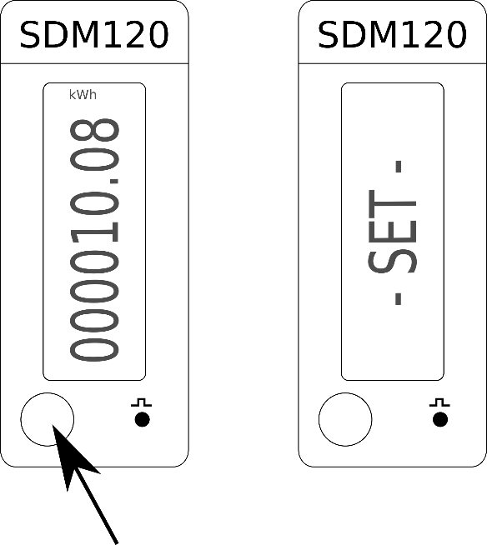

**Appendix II SDM630 configuration mode**

1. Hold down the **E** button until the screen is displayed to enter the password.
2. With the **M** button you can increase the number, with the **P** button you can decrease the number. By briefly pressing the **E** button you can move the cursor to the next position.
3. The default password is 1000. Confirm the password input by pressing button **E** until the screen displays **SEt Addr**.
4. The meter is in configuration mode when the screen displays **SEt Addr** .

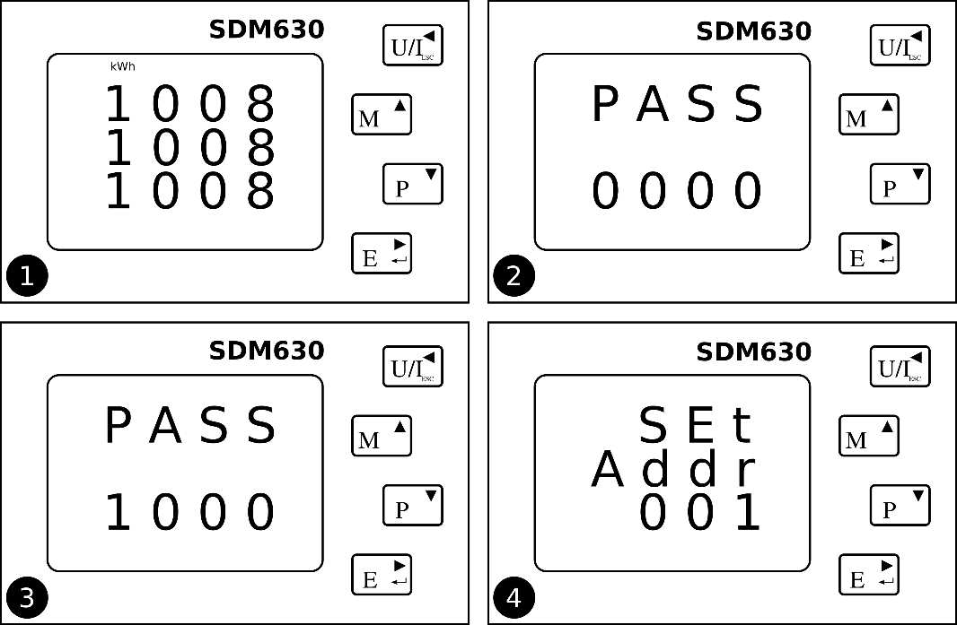

**Appendix III View meter address**

**SDM120**

By pressing the button on the meter, it is possible to scroll through the menu of the meter. Keep pressing the button until **Id** ***[address]*** will be displayed. The address of the meter is the number that is displayed after **Id**.

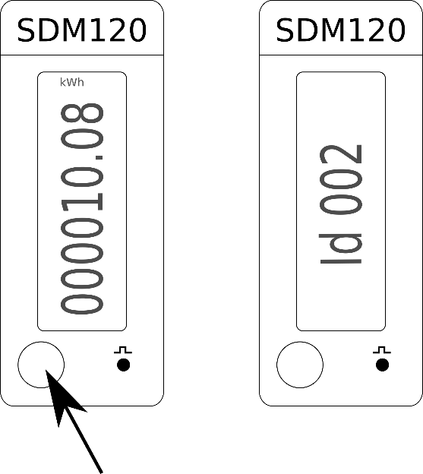

**SDM630**

See appendix **II** for the steps to view the meter address. The meter address is displayed in the **SEt Addr**  screen.

**Contact**

You can contact our support desk if you have questions about the installation. Our support desk is available on workdays (Monday – Friday) between 9:00 and 15:00.

To help you the best we advise you to contact us via email. In the email you can attach photos and screenshots that can help us identifying the problem.

For frequently asked questions, the operating instructions and manuals: ▶ **www.cemm.no/support**



**Cedel B.V.**

**Telephone +47** 90193166

**Email** larsalbert@cedelnorge.no

**Web** www.cemm.no