info26 **If you already have a kWh meter installed, it is possible to carry out step 5 yourself. All electrical installations should be carried out by a qualified electrician.**

**Step 5: Connect the CEMM basic with a kWh meter (e.g. for monitoring solar production)**

Connect the S0-cable with the S0 (pulse) output of the kWh meter. Make sure the polarity of the connection is correct. The green conductor is negative (-) and the black conductor is positive (+). Connect the other end of the S0-cable with **connection 2** of the CEMM basic.

**Step 6: Opening the CEMM basic application**

An internet browser is needed in order to view the CEMM basic application**.** Open your internet browser and browse to the following url:

**▶ Via http://zoek.cemm.nl (recommend)**

Go to <http://zoek.cemm.nl> in the browser. The website will search for your CEMM basic in the network andautomatically redirects to the CEMM basic application if both devices are in the same local network.

**▶ Via the hostname**

The CEMM basic will identify itself with hostname “cemm” in your local network. You can access the CEMM basic application by typing in the hostname in the browser.

On Windows computers: [**http://cemm**](http://cemm/)**/**

On Apple or Linux computers: [**http://cemm.local**](http://cemm.local/)**/**

**Attention:** The device you are using to access the CEMM basic needs to be in the same local network as the CEMM basic.

 **It is possible to access the CEMM basic outside of your local network. Enable the remote access feature in the CEMM basic application after the installation. You can find more information about remote access on our website ▶** [**www.cemm.nl/remote-access**](http://www.cemm.nl/remote-access)

**Step 7: Configure the CEMM basic**

The CEMM basic will startup in installation mode if the CEMM basic is not configured for logging. The installation mode will help you to configure the CEMM basic step by step.

 **The CEMM basic will install the latest software version during the installation, this may take several minutes. After the software is installed, you will be automatically redirected to the installation page**

**Contact**

You can contact our support desk if you have questions about the installation. Our support desk is available on workdays (Monday – Friday) between 9:00 and 15:00.

To help you the best we advise you to contact us via email. In the email you can attach photos and screenshots that can help us identifying the problem.

For frequently asked questions, the operating instructions and manuals: ▶ **www.cemm.nl/support**

|  |  |
| --- | --- |
| D:\Users\LBE\Desktop\phone16.png | +31 592 545 542 (Netherlands, local tariff) |
| D:\Users\LBE\Desktop\email21.png | [info@cedel.nl](mailto:info@cedel.nl) |
| D:\Users\LBE\Desktop\earth16.png | www.cemm.nl |
| D:\Users\LBE\Desktop\shopping122.png | www.webshop.cedel.nl |

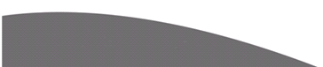

**Installation manual**

**CEMM basic**

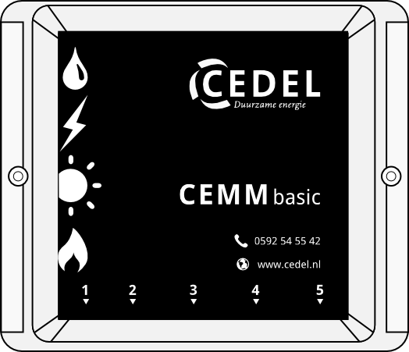



**Before installation**

This manual contains a step by step description of the CEMM Basic installation. Before installation check if all components listed below are included.

**Included in the package**

▶ CEMM basic

▶ Two screws + plugs

▶ Smart meter cable (P1)

▶ Power adapter

▶ Network cable

**Installation requirements**

▶ Network connection near the CEMM basic

▶ Wall socket near the CEMM basic

▶ Computer or Smartphone with internet browser

▶ Smart meter (optional)

**If you have solar panels**

**▶** 1 phase kWh meter/3 phase kWh meter with S0 pulse output.

▶ S0-cable

D:\Users\LBE\Desktop\info26.png **The parts needed for monitoring your solar modules are available on the webshop of Cedel: www.webshop.cedel.nl**

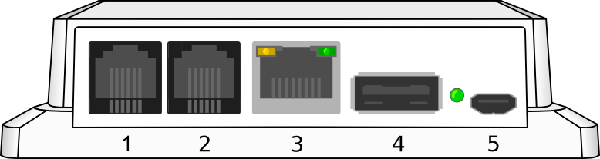

**CEMM Basic connections**

1. Smart meter (P1)

2. Solar panels (S0)

3. Network

4. USB (unused)

5. Power adapter

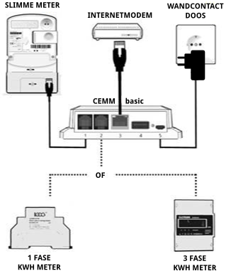

**Installation**

**Step 1: Mounting the CEMM basic**

Mount the CEMM basic on the wall with the screws included in the package. The CEMM basic needs to be mounted with the connectors facing down and the text on the front readable. Place the CEMM basic near an internet connection and wall socket.

**Step 2: Connect the CEMM basic with a smart meter**

The CEMM basic supports smart meters with the DSMR protocol and a P1 port. Skip this step if no suitable smart meter is available.

Use the included P1 cable to connect the smart meter with **connection 1** of the CEMM basic. Check the manual of the smart meter to locate the P1 port on the smart meter.

**Step 3: Connect the CEMM basic to the network**

Use the included network cable to connect the CEMM basic with your local network. Connect the other end of the network cable with **connection 3** of the CEMM basic.

**Stap 4: Connect the power adapter**

Connect the power adapter to **connection 5** of the CEMM basic. The CEMM basic will start automatically. The startup can take a few minutes. The LED next to the power connection of the CEMM basic will start blinking when the CEMM is ready.

**▶ Skip step 5 if you don’t have solar panels or other meters to connect with the CEMM basic.**